FIRST WEEK PROJECT
WEB PAGE

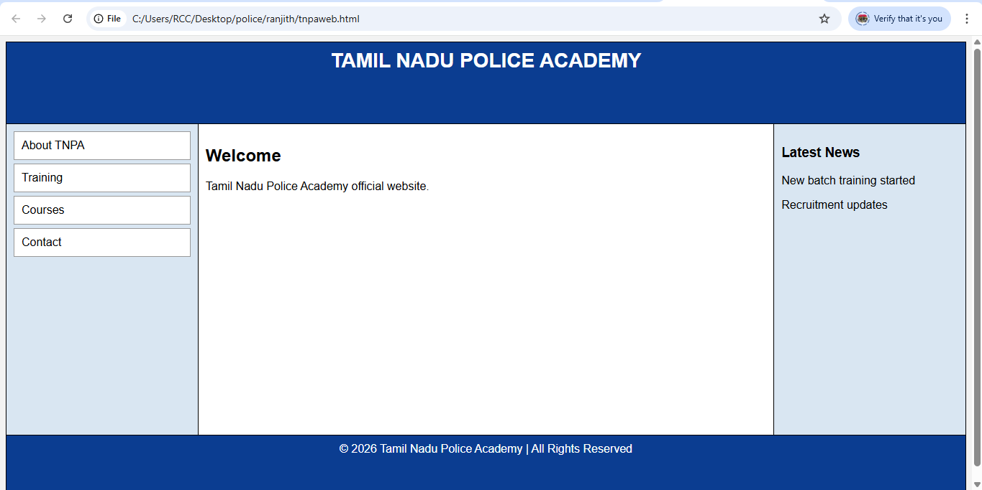

- It appears to be a basic HTML layout (likely using tables or simple CSS).
- No visible images or advanced styling.
- Simple 3-column structure (Left Menu | Main Content | News).
- Looks like a beginner-level web design project.
If you’d like, I can:
- Improve the design using modern CSS
- Make it responsive
- Convert it to a professional-looking layout
- Add navigation functionality
- Add styling with Bootstrap

SECOND WEEK PROJECT
CALCULATOR

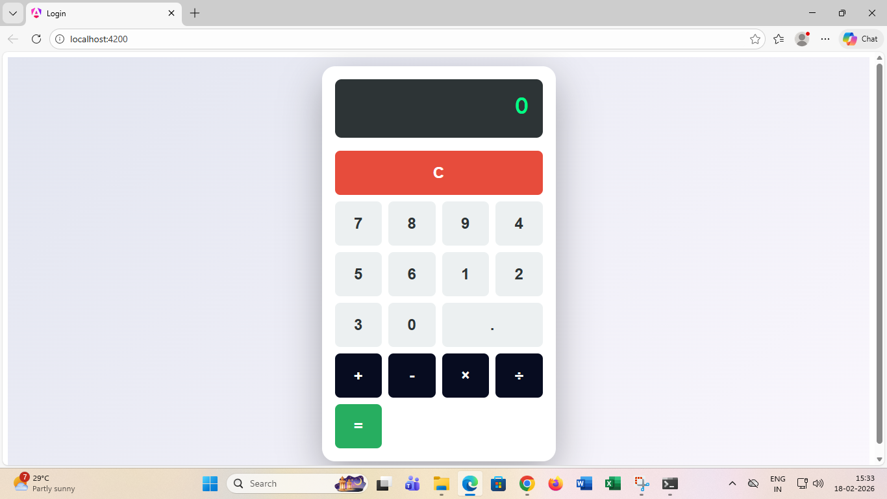
🔹 General Front-End Terms
- UI (User Interface) – Visual layout of the calculator
- UX (User Experience) – How easy and smooth it is to use
- Responsive Design – Adapts to different screen sizes
- SPA (Single Page Application) – Runs on one page without reload
🔹 Angular-Specific Terms
- Component – Main building block (e.g., CalculatorComponent)
- Template – HTML view of the calculator
- Interpolation ({{ }}) – Displays data on screen
- Event Binding ((click)) – Handles button clicks
- Property Binding ([ ]) – Binds values dynamically
- Two-way Binding ([(ngModel)]) – Syncs input and variable
- TypeScript – Logic written in .ts file
- Angular CLI – Tool used to run app (ng serve)

